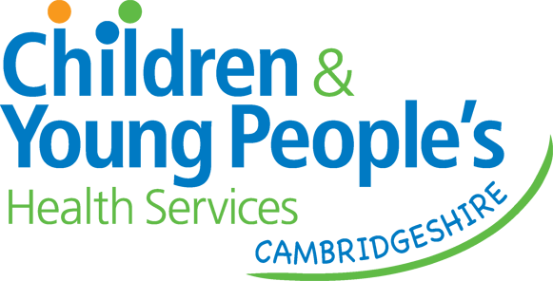

Cambridgeshire
Occupational Therapy

School Ready to Learn Pack

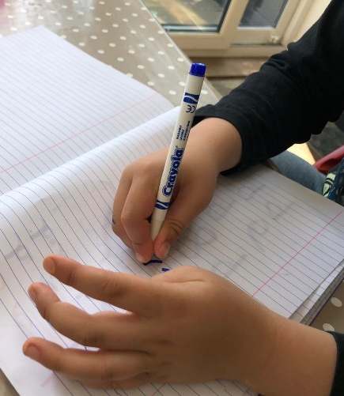 |  | 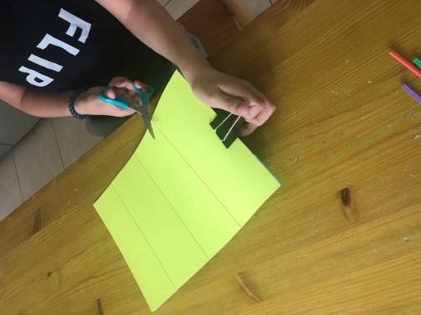

Occupational Therapy School Ready to Learn Pack

The purpose of this resource pack is to give school staff and parents ideas to support their children to practise and develop skills, prior to accessing our Advice Line or referring to Occupational Therapy.

We hope that by providing advice and strategies at a universal level, a more specialised and targeted service can be provided for children who are presenting with complex difficulties.

School staff and parents should work together and use this resource pack to help with developing an appropriate support plan as part of the Graduated Response to Supporting Children with Special Educational Needs (SEN)- Assess, Plan, Do, Review. For more information visit https://www.cambridgeshire.gov.uk/residents/children-and-families/local-offer/local-offer-care-and-family-support/send-information-advice-and-support-service-sendiass

This pack is intended as a guide only; the strategies are appropriate for children with motor skills difficulties. The Occupational Therapy service should always be consulted if;

- The need appears more complex than the solutions offered
- The child has a neurological condition e.g. Cerebral Palsy which may impact upon the appropriateness of strategies given
- The child has a degenerative condition and their needs are changing rapidly
- There are safety concerns related to the activity or strategies provided

The Occupational Therapy referral form can be found at https://www.cambscommunityservices.nhs.uk/what-we-do/children-young-people-health-services-cambridgeshire/contact

How to use the pack:
- Many of the ideas can be incorporated into Finger/Hand Gym sessions and Gym Trail sessions in school, but can also be incorporated into everyday activities in the classroom and at home during leisure activities. Many of the ideas can be delivered as whole school/whole class approaches and can be of benefit to many children and not just individuals with SEN.
- The recommended frequency of activities is detailed on the individual worksheets.
- The activities should be carried out for a minimum of one school term to allow for progress.
- Identify which difficulties the child is experiencing from the table below and then refer to the relevant worksheet.

What to do if expected progress is not seen:
- If the child is not making progress and/or school staff/parents feel further advice is required, then please contact our Advice Line as a referral to Occupational Therapy may be appropriate. If a referral is deemed appropriate, the worksheet/record forms in this pack can be used to support the referral as they provide evidence of strategies already trialled.
Cambridgeshire Community Services Occupational Therapy Service currently does not offer a diagnostic service for Developmental Coordination Disorder or Dyspraxia.

Area of Difficulty | Page Number
Early Pencil Skills and Reluctant Writers | 3-14
Handwriting | 15 - 23
Using IT to Write | 24 - 27
Scissor Skills and Using a Ruler | 28 - 30
Attention and Focus  Including guidance for:  - Move n sit cushions  - Weighted Products  - Now and Next Boards | 31 - 35
Organisational Skills | 36 - 37
Sitting Posture | 38 - 10
Balance, Coordination and Motor Planning | 41 - 45
Ball Skills | 46 - 47
Dressing Skills | 48 - 53
Cutlery Skills | 54 – 55
Toileting | 56 - 57
Washing Body and Hair | 58 - 60
Managing Periods | 61 - 62

