Information and Guidance for referrers to
Cambridgeshire Community Services NHS Trust’s Children’s Occupational Therapy Service

What is Occupational Therapy?

The core purpose of Occupational Therapy for Children and Young People is to empower and enable the child/young person and their family to live their lives as independently and easily as possible.

The Children’s Occupational Therapy (OT) service is an integrated service which helps children and young people (CYP) participate in normal everyday activities such as play, participation in activities at school/nursery as well as managing personal care (dressing, bathing, getting on and off the toilet and getting in and out of the bath).

We also support CYP by giving advice on adapting environments both at home and at school to make these safe and accessible. We want to help children and young people lead full and happy lives, to realise their potential and to take part as valued members of their community.

We recognise that parents/carers are the expert on their child and the situation, we will offer our knowledge and skills to support them to help their child.

The Occupational Therapists and support staff work as part of a multi-disciplinary/multi agency team to provide an integrated family centred approach to therapy provision.

Occupational Therapists believe that taking part in everyday activities (Occupations) improves well-being and enables people to live safe, happy, and healthy lives. We support you by thinking about you (the child) what you want to do (the Occupation) and the environment.

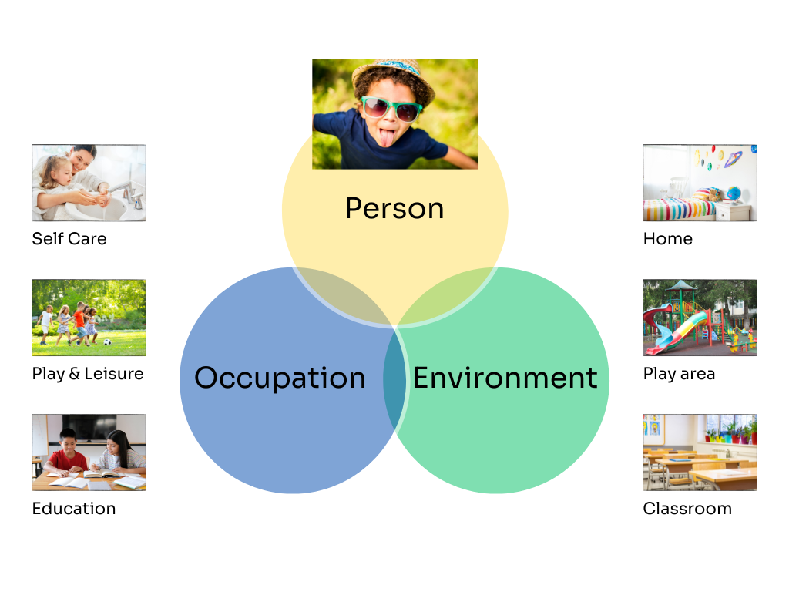

Where We Work
The Occupational Therapy Service has two core teams located in North and South Cambridgeshire and a housing team that works across both areas.

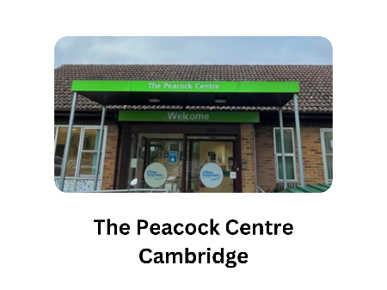
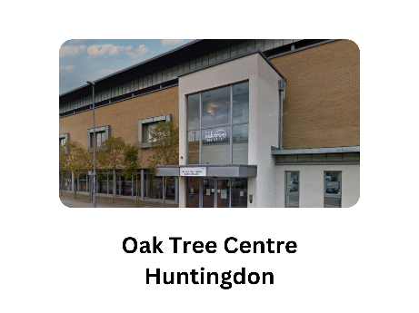
The North team are based and offer clinic appointments at the Oaktree Centre in Huntingdon and New Horsefair Clinic in Wisbech.

The South Team are based at The Peacock Centre in Cambridge and Highfields Academy in Ely.

We also have dedicated therapists who work with CYP with Myalgic encephalomyelitis/chronic fatigue syndrome (ME/CFS)

The Occupational Therapy service also provides a hand splinting service on receipt of referral.

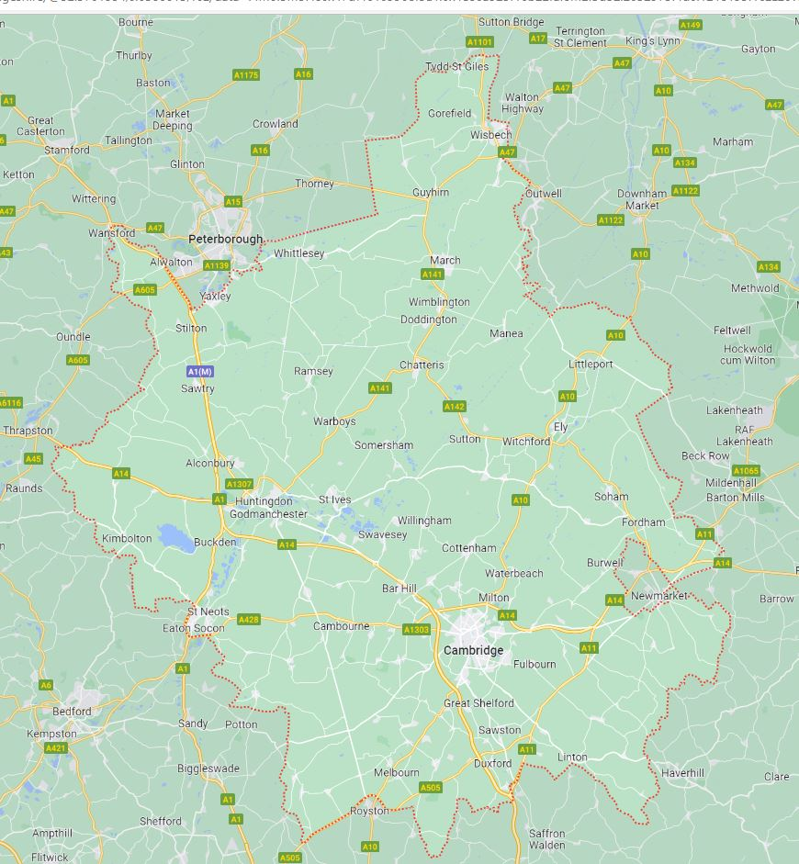
We have a service level agreement with Cambridge University Hospital (Addenbrookes) and have Occupational Therapists who work within the Long Covid service for children and young people which covers Cambridgeshire and Peterborough.

We also provide Occupational Therapy intervention for children on the Neonatal unit, Brainbow Team and at specific clinics e.g. Rheumatology.

Some of the Children’s Occupational Therapy team provide intervention via agreements to individual specialist schools supporting CYP with neurodiversity.

Our service is commissioned to provide Moving and Handling training for mainstream school staff on behalf of the local Authority.

This is booked via Event-brite, details are available on the Trust’s Children’s Occupational Therapy website page.
www.bit.ly/ot-backcaretraining

We work within a Tiered Model Approach which is a supported model of service delivery recommended by the Royal College of Occupational Therapy

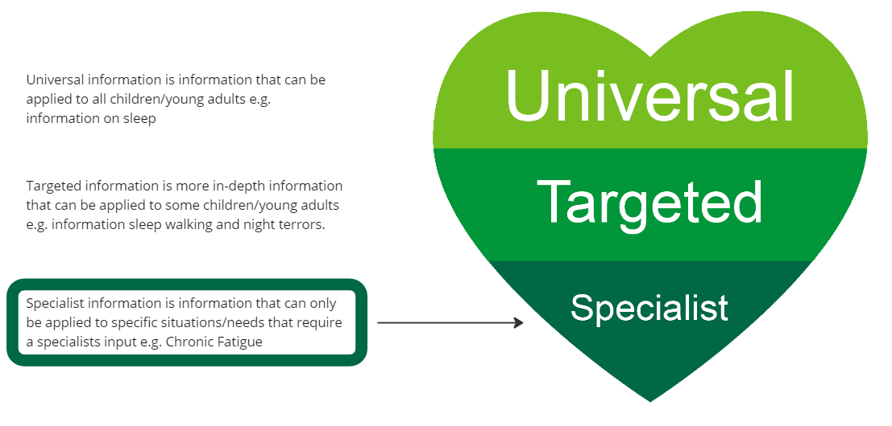
We provide advice at a Universal level via our website on normal development; hand skill development, play, activities of daily living (getting dressed, mealtimes, sleep, self-care, posture and seating), early drawing skills and safety in the home: www.bit.ly/otcoreoffer

Our universal offer also includes:
- Information and advice via our Telephone Advice Line for parents and professionals.
Occupational Therapy Advice Line
By providing early help and advice around Occupational Therapy issues, unnecessary referrals and wait times can be prevented. This can also be the first step in providing a family with practical strategies, before a referral needs to be made.

- An Occupational Therapist will be available to answer queries from parents, school staff and health professionals where the child/young person is not already receiving care from the service.
- The phone line will be open Monday and Thursday 0930 – 1100 and Wednesday 1430 – 1600. Tel Number: 0300 029 50 50.
- It is available to discuss children/young people aged 0-18 years (up to 19 years if in full time special school education).
- The child/young person must be registered with a Cambridgeshire GP.
- Families can contact us to gain practical therapy advice, strategies, and support in relation to a child’s functional and independence skills.

- Training for education staff in special schools covering physical needs, sensory needs and life skills to develop the staff’s knowledge of some of the difficulties children may have and how they can support them.
- Training for other healthcare/other agency professionals – health visitors, Emotional Health and Wellbeing Service, Educational Psychology, Local Authority (case workers), social care (social workers)

Targeted intervention
- Website based - including handwriting development, drawing skills, scissor skills, information and strategies for motor skills/co-ordination, sensory differences, and safety in the home,
- Resource pack for mainstream schools, including resources for handwriting and self-care activities.
- SCILS (Social Communication, Interaction and Learning) and CYGNET Parent Information Programmes offering Occupational Therapy lead sessions on sensory differences and their impact on development of functional skills.
- Targeted training for special schools and mainstream schools.

Specialist Intervention
- Assessment of needs, a child’s occupation, housing, selfcare, equipment prescription, moving and handling at home and in educational environments. Direct Interventions related to function and participation e.g., splinting, Modified Constraint Induced Movement Therapy, independence skills.

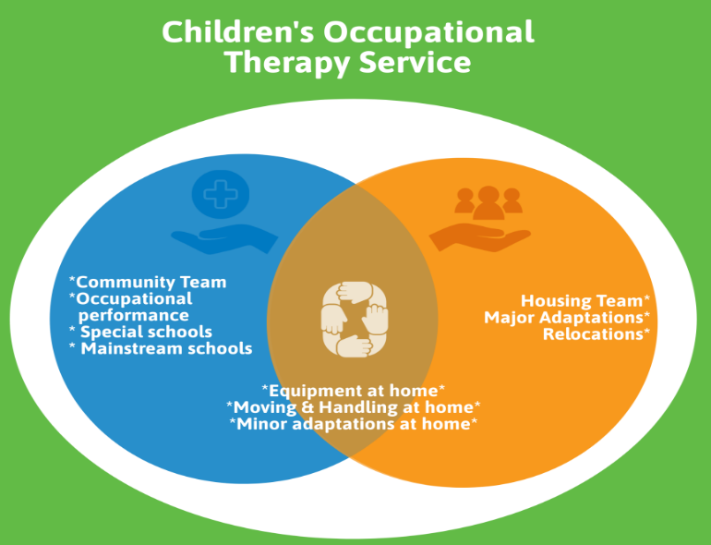

We are an Integrated Service which means that within the same service, we deliver input across home, school and other educational settings.

Referrals

- Referral to our service can made by parents, schools, GPs and other healthcare and social care professionals.
- Please see below for our triaging criteria. If you are confident that the CYP you are referring meets the criteria as outlined, you can initiate a referral using the OT referral form which can be found on our website: www.bit.ly/otcoreoffer.
- All sections of the referral form must be completed.
- we require adequate information about a child, including family background/home setting, academic ability, social functioning, and the child’s challenges. Any incomplete forms will not be accepted and will be returned to the Referrer. It is very important that consent is gained from parents /carers and indicated on the form, otherwise we will be unable to proceed with processing the referral.
- It is essential that the process above is followed and that details are included of the assistance and intervention that has already been put in place to support the child, including information on how long this support has been in place and the outcome.

- All referrals are then triaged against our referral criteria and, if accepted, are allocated an appointment.
- If you need further advice regarding a potential referral to our service, please do contact us via our Advice Line.

Referral Criteria
A Clinic Assessment Appointment may be offered where:
- The child’s difficulties have a significant impact on their ability to access the educational curriculum e.g., handwriting, using tools such as scissors, ruler, etc.
- The child’s difficulties are having a significant impact on their well-being and self-esteem because of poor hand function.
- The child’s difficulties are having an impact on their independence skills such as managing cutlery, dressing skills and hygiene.
- Parents/Carers/School have accessed the advice and strategies given on our website for a minimum period of 3 months (one-term).
- School have already implemented school-based interventions and more specialist assessment and advice is needed.

We wouldn’t be able to accept a referral if:
- There is no evidence that universal/targeted strategies have been tried by school staff.
- There is insufficient evidence that any underlying difficulty is having a major impact on the child’s access to the curriculum, functional abilities, development and/or well-being.
- The child is in Reception or Year 1 and the request is for a handwriting assessment.
- The level of the child’s motor skills ability appears to be broadly in line with the level expected for their age, developmental level and diagnosis/disability.
- The difficulty could be expected to be resolved or improved with intervention from other service providers (e.g. specialist teaching service or educational psychologist) and the identified needs do not fall within our area of specialism and associated core offer.

Workshops for Parents/Schools to further discuss needs related to sensory differences/regulation:
- School Workshops to be launched in the autumn 2023.
- Parent/Carer can be referred to SCILS/CYGNET parent information course via Early Help
An Assessment of a child/young person’s needs related to housing will be
offered where they are:
- Significant housing needs where the child does not have safe and appropriate access to a bedroom, bathroom, toilet, main family living area, garden, access in/out of the property. This includes promoting safety for carers or the child’s independence.
- Significant risks for the child (or child putting other family members at risk) around the house and garden where specialist advice is required relating to the physical environment.
- Significant difficulty accessing the kitchen to participate or prepare food appropriate to the child’s age and developmental level.
- There is evidence that physical rehabilitation interventions have been tried and would not be expected to resolve the underlying need.

We wouldn’t be able to accept a referral if:
- The concern relates to repairs to Disability Facility Grant (DFG) equipment and as such remains the responsibility of the parent. In these circumstances, a warranty is included in DFG during the first 5 years and parents are responsible for service and repair of equipment after the first 5 years. If the parent needs advice, they should contact the Home Improvement Agency in the first instance.
- The concern relates to a need for repairs to property e.g., fencing, pathways and, as such remains the responsibility of the parent.
- The concern relates to equipment which is widely available (e.g., by searching on-line) and could be expected to resolve the difficulty. For example: mainstream highchair, mainstream toilet step, window locks
- There is no evidence to suggest that behaviour management interventions (or other parental interventions have been tried.

A Joint Occupational Therapy and Physiotherapy Clinic appointment will be offered where:
- The child has a complex physical disability/ neurological impairment affecting movement and function.
- There is significant disability/movement impairment affecting the child’s ability to access daily living, play or school activity which cannot be managed with mainstream strategies and requires specialist advice. For example: Moving and handling assessment and intervention, gross and fine motor assessment and advice, specialist advice on increasing independence (dressing, eating), specialist advice on accessing the school environment and activities (e.g., accessing the sand pit, the toilet or the science lab).
- Provision and/or advice on specialist equipment is required to improve postural care, promote independence, or ensure safety. For example: Specialist bath seat, specialist seating to enable eating or play, specialist toilet seat for a child that cannot maintain a seating position, sign posting for car seat, specialist feeding equipment, post-surgery equipment.

