Information and Guidance for referrers to
East of England Health and Care NHS Trust’s Children’s Occupational Therapy Service – HOUSING

What is Occupational Therapy?

The core purpose of Occupational Therapy for Children and Young People is to empower and enable the child/young person and their family to live their lives as independently and easily as possible.

The Children’s Occupational Therapy (OT) service is an integrated service which helps children and young people (CYP) participate in normal everyday activities such as play, participation in activities at school/nursery as well as managing personal care (dressing, bathing, getting on and off the toilet and getting in and out of the bath).

We also support CYP by giving advice on adapting environments both at home and at school to make these safe and accessible. We want to help children and young people lead full and happy lives, to realise their potential and to take part as valued members of their community.

We recognise that parents/carers are the expert on their child and the situation, we will offer our knowledge and skills to support them to help their child.

The Occupational Therapists and support staff work as part of a multi-disciplinary/multi agency team to provide an integrated family centred approach to therapy provision.

Occupational Therapists believe that taking part in everyday activities (Occupations) improves well-being and enables people to live safe, happy, and healthy lives. We support you by thinking about you (the child) what you want to do (the Occupation) and the environment.

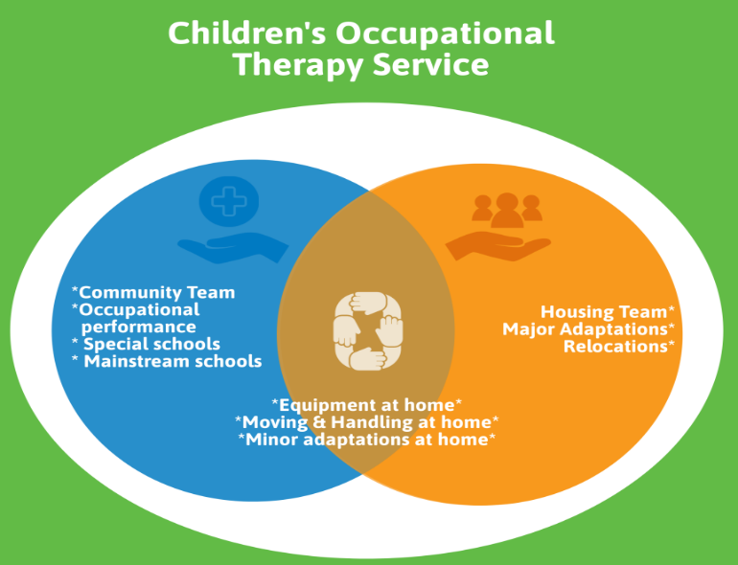

We are an Integrated Service which means that within the same service, we deliver input across home, school and other educational settings.

The Housing team sits within the Occupational Therapy Service working across the County of Cambridgeshire. At times, you may receive support from both the community occupational therapist and the housing occupational therapist. The housing specialist team will help you to help your child/young person in your home.

We work within a Tiered Model Approach which is a supported model of service delivery recommended by the Royal College of Occupational Therapy. It is an expectation from the service that a universal level has been applied, as appropriate before a referral is made.


Following Assessment, a specialist level of input will determine the clinical needs relating to your home environment.

Universal information on ‘how you can help your child/young person’ that can be applied to all children/young adults. See examples below of actions you do not need a professional referral for.
Following Assessment, a targeted level of support will be advice and strategies to best meet needs. It is likely to be a shorter episode of care.

Universal information: Here are examples of actions you do not need a professional referral for:

- Access parent/carer support via https://www.cambridgeshire.gov.uk/residents/children-and-families/parenting-and-family-support
- sleep support (self referral) (https://send.cambridgeshire.gov.uk/kb5/cambridgeshire/directory/site.page?id=HvLt6159seQ
- Technology Enabled Care (self referral) (https://www.cambridgeshire.gov.uk/residents/adults/staying-independent/equipment-and-technology/technology-enabled-care
- Generally available safety equipment –for example, install window restrictors, magnetic cupboard locks, stair locks, socket covers, oven door knob cover and fridge locks, access to Fledglings for adaptive clothing (https://www.fledglings.org.uk/?srsltid=AfmBOorUnZPARMr-RAA-bW38g63N2YMX5Uux1P8AGAq6bT6t1WQSO6if
- strategies for those with sensory differences (https://cambspborochildrenshealth.nhs.uk/services/cambridgeshire-childrens-occupational-therapy-service/online-learning-and-training/sensory-differences-training-for-families/

- Other equipment which is readily available; bath and toilet step, kitchen aids, grab rails.

Referrals

A housing Occupational Therapy assessment is a structured professional evaluation of how a child or young person uses and is affected by their home environment and whether changes to the home are clinically appropriate to meet their needs for daily living and participation.

An assessment is not a guarantee that adaptations will be approved or funded.

- Referral to our service can made by parents, schools, GPs and other healthcare and social care professionals.
- Please see below for our triaging criteria. If you are confident that the CYP you are referring meets the criteria as outlined, you can initiate a referral using the OT referral form which can be found on our website: Cambridgeshire Children's Occupational Therapy
- All sections of the referral form must be completed.
- we require adequate information about a child, including family background/home setting, academic ability, social functioning, and the child’s challenges. Any incomplete forms will not be accepted and will be returned to the Referrer. It is very important that consent is gained from parents /carers and indicated on the form, otherwise we will be unable to proceed with processing the referral.
- It is essential that the process above is followed and that details are included of the assistance and intervention that has already been put in place to support the child, including information on how long this support has been in place and the outcome.

- All referrals are then triaged against our referral criteria and, if accepted, are allocated an appointment.
- If you need further advice regarding a potential referral to our service, please do contact us via our Advice Line. https://www.cambspborochildrenshealth.nhs.uk/services/cambridgeshire-childrens-occupational-therapy-service/advice-line/

REFERRAL CRITERIA

An Assessment of a child/young person’s needs related to housing will be
offered where they are:

- Evidence of universal strategies being employed and in place for a minimum of 10-12 weeks, where appropriate.

- Significant housing needs where the child does not have safe and appropriate access to a bedroom, bathroom, toilet, main family living area, garden, access in/out of the property. This includes promoting safety for carers or the child’s independence.
- Significant risks for the child (or child putting other family members at risk) around the house and garden where specialist advice is required relating to the physical environment.
- Significant difficulty accessing the kitchen to participate or prepare food appropriate to the child’s age and developmental level.
- There is evidence that physical rehabilitation interventions have been tried and would not be expected to resolve the underlying need.

We wouldn’t be able to accept a referral if:

- There is no evidence that universal strategies have been tried, as appropriate.
- The concern relates to repairs to Disability Facility Grant (DFG) equipment and as such remains the responsibility of the parent. In these circumstances, a warranty is included in DFG during the first 5 years and parents are responsible for service and repair of equipment after the first 5 years. If the parent needs advice, they should contact the Home Improvement Agency in the first instance.
- The concern relates to a need for repairs to property e.g., fencing, pathways and, as such remains the responsibility of the parent.
- The concern relates to equipment which is widely available (e.g., by searching on-line) and could be expected to resolve the difficulty. For example: mainstream highchair, mainstream toilet step, window locks

