Organisational Skills

Organisation is dependent on having adequate motor planning, body awareness, timing, focus/attention and memory. Organisational skills are the basis of daily routines and impact a child’s ability to gain independence. The key to supporting children to become more organised is teaching them strategies that they can use, rather than relying on an adult to prompt them and correct their mistakes.

Area of Difficulty | Strategy | Tick when strategy has been tried and add comments.
Child struggles to get ready on time | Break down activities into smaller steps. Write down instructions or use simple visual schedules to help prompt. The child can tick the tasks off as they compete them.
 | Try to minimise distractions, a child may need to get ready in a quiet space so they can focus on the steps of the task. Ensure the space is clutter free.
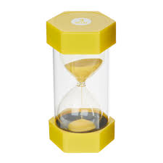
Use a sand timer and prompt the child to refer back to this if they lose focus.

Child struggles to pack their school bag and organise their belongings. They may frequently lose objects. | Encourage the child to pack the bag in advance e.g., the night before when there is less time pressure
 | Label the child's belongings so they know which items they need to pack in their bag to bring home
 | Choose a school bag with compartments and encourage the child to allocate compartments for certain items.
 | Use a checklist for the child to tick off when they pack an item. Create the list with the child using the school timetable to encourage them to plan what items they need.
 | Use visual cues so it is clear where the child needs to put their belongings e.g., name/picture above coat peg/PE peg
 | Encourage the child to help sort objects into different criteria e.g. size, shape, texture, colour, length, purpose. This could be when tidying toys after playing or putting away clothes
Child finds it difficult to collect materials needed for lessons or home/school leisure activities | Break the task down into smaller simple steps. E.g. ask the child to collect a specific item.
 | Encourage the child to help with tidying up. Label trays/cupboard doors/baskets with words and pictures so they child can locate where the items belong easily.
Child struggles to follow school/home routines | 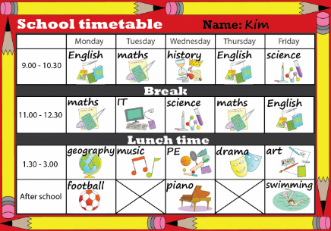  Provide the child with a timetable of the school day, either using words or pictures. Lessons could be colour coded.
 | Ask the child to check their timetable at the end of each lesson, rather than them relying on you telling them what is next
 | Keep routines consistent where possible so the child can learn what is expected

