SEND Service 0-25 Years
Autism in Girls Checklist
For use in Primary Schools
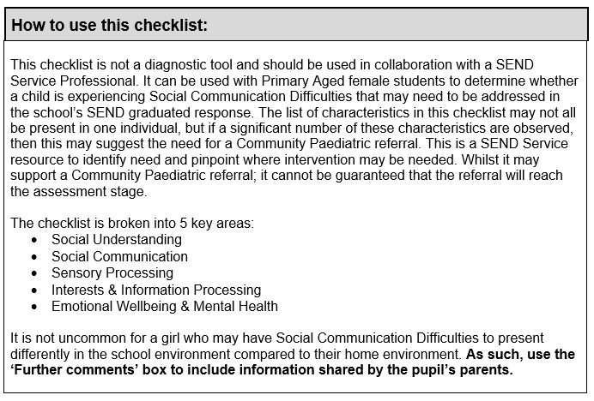
Child/Young Person name:
Date of Birth & Year group:
School/Setting Name:
Name of person(s) completing checklist & role:
Date of completion:

Social Understanding:  Differences in understanding social behaviour, understanding the feelings of others, how to start an informal conversation and forming friendships.  To what extent are the following characteristics observed in the pupil at school? | Always | Often | Sometimes | Never
Difficulties recognising the status/ authority of themselves e.g., seeing a rule as applying to other children, but not themselves.
May present themselves as an adult, e.g., role playing being the teacher or interest in more mature activities, such as cooking, cleaning, construction.
Preference for playing or socialising with boys, over girls
Lacks a close friend, or has just one or two intense friendships
May appear to dominate other children during play or unstructured activities e.g., wanting to control the rules during a playground game
Can form friendships, but experiences difficulties maintaining healthy friendships e.g., frequent fallouts on the playground
May show a preference of spending playtime with school staff, rather than peers
May play more successfully with younger children
Imaginative play may lack the ability to predict the consequences of their actions and the actions of others
May struggle with group work, or show a preference for working solo
Experience difficulties asking for help e.g., will persevere with work they find difficult without asking a teacher for help
May be very loyal and trustworthy in friendships e.g., will stick up for a friend in a peer conflict
Can appear very honest e.g., commenting on a person’s appearance in a factual way
Can appease others or say what they think others want to hear
May ‘camouflage’ their difficulties e.g., saying they know what to do in a social situation when they are confused
Appears exhausted from trying hard to socialise or ‘blend in’* at school
*Blending: an attempt to fit in with others
Strong sense of moral justice and described as seeing the world in ‘black and white’
Finds it difficult to understand or accept another person’s viewpoint e.g., becomes frustrated when someone disagrees with their opinion
Struggles to understand the impact of their actions or comments on another person’s feelings e.g., not understanding that a factual comment about someone’s appearance can be interpreted as rude
Can be described as hypervigilant e.g., acutely notices when a new or unfamiliar person enters the classroom
May skilfully use doll play or imaginary friendships to decode social situations
May be described as good at following the school rules
Further comments: (Inc. parents’ views)

Social Communication:  Differences in understanding communication and language, jokes, sarcasm, tone of voice, facial expression, and gestures  To what extent are the following characteristics observed in the pupil at school? | Always | Often | Sometimes | Never
Struggle to follow verbal instructions
Difficulty answering open questions
Overuse of stock/ learnt/ scripted phrases
May successfully observe and copy behaviour e.g., using a learnt script when meeting new people, or copying peers to follow an instruction in class
May possess skilled observation skills
Behaviour or communication appears analytical or learnt rather than intuitive
Literal understanding of language e.g., difficulties understanding metaphors or sarcasm
Appears shy or passive in new or unfamiliar social situations
May shows signs of selective mutism in certain situations or environments, despite talking at home
May not want to be the centre of attention or have the spotlight on them
May experience difficulties initiating conversations or maintaining conversations
Difficulties following another’s agenda in conversation e.g., can talk eloquently about their own interests, but struggle to follow another person’s point of view
Reluctance to answer questions in front of the class
Difficulties with appropriate facial expressions and responses e.g., her facial expression does not always match her mood or the situation
Difficulties reading other’s body language and facial expressions
May be able to learn ‘scripts’ successfully
May appear to have good expressive language skills or ‘mature’ language for their age
Inability to understand jokes or makes jokes that others do not understand
Further comments: (Inc. parents’ views)

Sensory Processing:  Differences in perceiving sensory information, hypo (low sensitivity), hyper (high sensitivity), touch, sight, hearing, smell, taste, vestibular (balance), proprioceptive (body awareness)  To what extent are the following characteristics observed in the pupil at school? |  | Always | Often | Sometimes | Never
Hyper (high) sensitivity: | Touch, e.g., resistant to hugs or dislikes hair being brushed
 | Sight, e.g., sensitive to bright lights
 | Hearing, e.g., overly sensitive to specific sounds or noise or cannot focus within a noisy environment
 | Smell, e.g., dislikes the smells of specific foods
 | Taste, e.g., restrictive diet due to flavours and/or textures
 | Vestibular, e.g., avoids movement, such as feet being off the ground or may easily experience motion sickness or dizziness
 | Proprioceptive, e.g., difficulties manipulating small objects
Hypo (low) sensitivity: | Touch, e.g., enjoys deep pressure activities or is attached to touching a certain toy to calm herself
 | Sight, e.g., attracted to flashing lights
 | Hearing, e.g., under reactive to loud or sudden noises or own name
 | Smell, e.g., does not notice or react to strong odours
 | Taste, e.g., prefers foods with strong flavours, such as spicy food
 | Vestibular, e.g., seeks movement involving rocking, swinging, or spinning without appearing dizzy
 | Proprioceptive, e.g., difficulties judging personal space and appear clumsy
May experience sensory overload*
*Sensory overload: when one or more of the body’s senses experiences intolerable or excessive over-stimulation from the environment
Further comments: (Inc. parents’ views)

Interests & Information Processing:  Differences in perception, planning, understanding concepts, generalising, and predicting, transitions and passions for interests.  To what extent are the following characteristics observed in the pupil at school? | Always |  | Often |  | Sometimes | Never
May have intense interests that are specific and restricted. These may be similar to most girls, e.g., books or fashion, but more passionate
May have a love of technology, horses, animals, reading or friendships
May have a particular subject strength or specialist in-depth knowledge e.g., in art or mathematics or music
May perform better with more concrete learning e.g., mental arithmetic, word decoding etc.
Differences in appearance to peers in terms of clothing e.g., preference for wearing boys’ clothes
May talk about one particular topic frequently and in a factual way e.g., showing a specialist in-depth knowledge about a specific topic
Difficulties starting work or stopping work that is unfinished
Difficulties with change or transitions e.g., experiencing anxiety when there is a change of staff or change to school routines
Rigidity in daily routines or governed by time
May engage in repetitive behaviours e.g., tapping hands on desk or picking at their fingers
May engage in repetitive questioning or commenting e.g., asking the questions about an upcoming new event
Perfectionist, such as during work tasks e.g., will become upset if piece of work does not go the way they planned
May be a model student and produce work of a very high calibre
May experience a fear of failure and making mistakes e.g., preventing them from even attempting a task or activity
Difficulties processing lots of information at once e.g., may need learning tasks to be presented one step at a time
May become fixated on a mistake or upset and appear unable to move passed it
Further comments: (Inc. parents’ views)

Emotional Wellbeing & Mental Health:  To what extent are the following characteristics observed in the pupil at school? | Always |  | Often |  | Sometimes | Never
Presents symptoms typical for low mood e.g., feeling sad, hopeless, trouble sleeping or changes in appetite
Presents symptoms typical for anxiety e.g., dizziness, feeling lightheaded, frequent urination, feeling cold or blushing or stomach aches
Presents symptoms typical for panic attacks e.g., laboured breathing, sweaty or having chills, chest pains, sense of terror
May experience ‘meltdowns’ e.g., outward signs of extreme distress such as crying, shouting, exiting the classroom
And/ or, experiences ‘shutdowns’ e.g., internalising distress becoming silent, withdrawn and unable to communicate
Expresses or shows feelings of worry or anxiety e.g., will ask lots of questions, seek reassurance, repeats information.
May become emotionally distressed for apparently trivial reasons
Lack a sense of personal identity
May have low self-esteem
May lacks certainty about gender, such as rejecting ‘feminine’ clothing or displaying a desire to present as male
May ‘mask’ anxiety/ difficulties in one environment (i.e., school) and then appear to not cope in another environment (i.e., home)
*Masking = the ability to hide or hold in your anxiety so you appear calm
Appears compliant and passive in school, but can demonstrate difficult behaviours at home
Further comments: (Inc. parents’ views)

References:
- Carpenter, B., Happé, F. & Egerton, J. (Eds.), (2019) Girls and Autism: Education, Family and Personal Perspectives. London & New York: Routledge

- Loomes, R. et al., (2017) ‘What is the Male-to-Female Ratio in Autism Spectrum Disorder? A Systematic Review & Meta-Analysis’, Journal of the American Academy of Child & Adolescent Psychiatry, 56(6), pp. 466-474

- NASEN, Carpenter, B. & Egerton, J. (2016), Girls and Autism: Flying under the radar’. Available at:
https://www.nasbtt.org.uk/wp-content/uploads/2020/07/flying-under-the-radar-miniguide-autism.pdf (Accessed: 19 March 2021)

- National Autistic Society, Autistic women and girls. Available at:
https://www.autism.org.uk/advice-and-guidance/what-is-autism/autistic-women-and-girls (Accessed: 19 March 2021)

- National Autistic Society, Women and girls online training module. Available at:
https://www.autism.org.uk/what-we-do/professional-development/training-and-conferences/online/women-and-girls (Accessed: 19 March 2021)

- Staffordshire County Council, Autism in Girls Checklist. Available at:
https://www.staffordshire.gov.uk/Education/Access-to-learning/Graduated-response-toolkit/School-toolkit/Communication-and-interaction/Social-communication-autism/SEN-support-in-school/Autism-in-Girls-checklist.pdf (Accessed: 19 March 2021)

- The students of Limpsfield Grange School & Martin, V., (2015) M is for Autism. London & Philadelphia: Jessica Kingsley Publishers

