Please see further information videos at Cambridgeshire Children in Care Health Service (cambspborochildrenshealth.nhs.uk) or use these QR codes
Food and drink
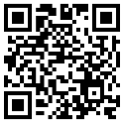
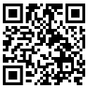
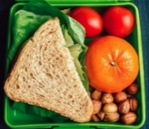


Why turn up? What’s it about?
Sleep


Growing and changing

and changingt
Medicine
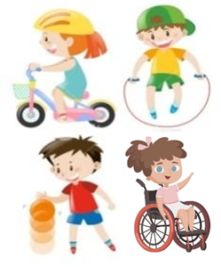
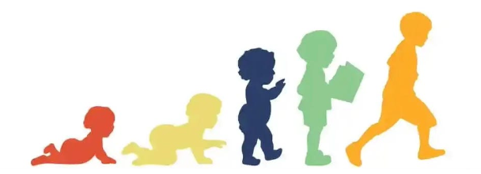
Keeping active
Learning

Teeth
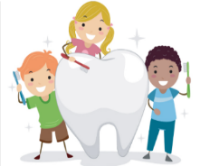
Height and weight

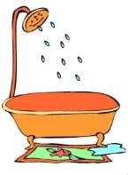

Culture/faith/religion
Washing and toileting

How I’m feeling

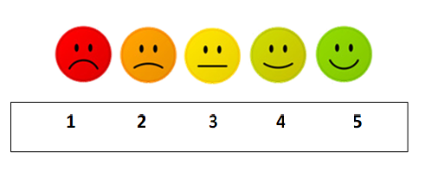
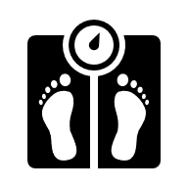
Medicine
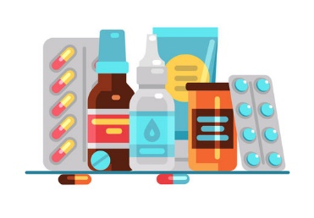
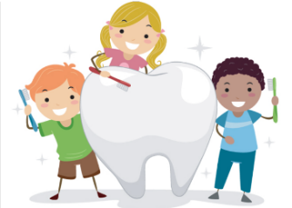
Teeth
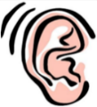
Hearing

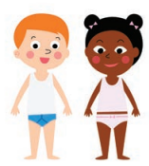

Keeping safe
Vision

My friends and family

Help us make changes
Calling all Children and Young People!
If you would like to help improve the service we offer, please email us at:
ccs.co-production@nhs.net
Or scan the QR code to register your interest!
Any questions?

Learning
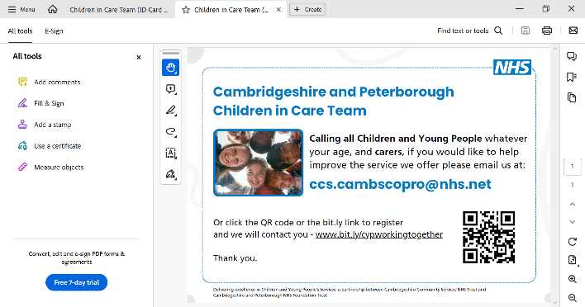
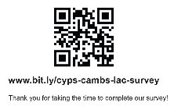
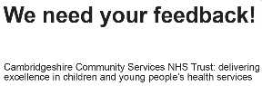
Please see further information videos at Cambridgeshire Children in Care Health Service (cambspborochildrenshealth.nhs.uk) or use these QR codes
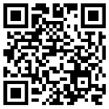
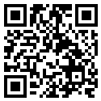
Helps us make changes Why turn up? What’s it about?
Calling all Children and Young People!
If you would like to help improve the service we offer, please email us at:
ccs.co-production@nhs.net
Or scan the QR code to register your interest!
Education
Health
Care Plan (EHCP)
Additional needs
Emotional wellbeing
Strengths and
Difficulties Questionnaire (SDQ)
Friendships

Questions about my health
Substance use
E-safety
Self-harm
Puberty
Consent
Contraception
Screening
Dentist
Optician
Hearing
Skincare
Diagnosis
Illnesses
Accidents
Medication
Growth
Height and weight-Body Mass Index (BMI)
Likes
Dislikes Goals
My Wishes
Keeping Myself Safe
Healthy Lifestyle
Looking After My Own Health
Height & Weight
Physical Health
Current Health
Anything Else???
Sexual Health & Relationships
My Family
How I feel
Learning and Development
Me & My Health
Diet
Activity
Sleep
Gender
Daily self-care
Independent skills
Family time
Unaccompanied Asylum Seeker
(UASC)

Culture
Faith
Religion
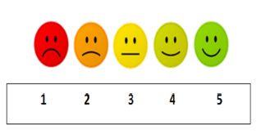
Culture/faith

