Balance, Coordination and Motor Planning

Some children struggle with balancing due to poor core strength. Other’s struggle due to instability of their joints. For some, it can be a fear of falling that limits their practise opportunities. Some children lack general coordination skills which makes them appear clumsy and awkward. It can take these children longer to learn unfamiliar motor skills and sequence movements.

Children with more significant gross motor concerns e.g. deteriorating or loss of skills, difficulties getting up from the floor, significant trips and falls, pain etc should be referred for physiotherapy assessment https://www.cambscommunityservices.nhs.uk/what-we-do/children-young-people-health-services-cambridgeshire/contact

Area of Difficulty | Strategy | Tick when strategy has been tried and add comments.
Child has difficulty balancing | Offer regular opportunities to practise core stability (see sitting posture ideas) and balance activities. These ideas should be completed in PE/Gym Trail sessions and at home at least 3 times a week for 15-20mins.  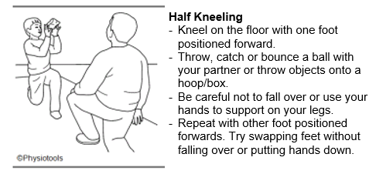  Box/Ball Balance  - Stand on one leg with the other foot resting on a low box or ball for 1, 2, 3... etc aim to beat your own record.  - A slightly deflated ball would be easier to start with as it wont roll around so easily.  - Try rolling the ball forwards, backwards and to the sides just using your foot.  - Roll the ball to the child and see if they can stop it by placing their foot on top of it. See if the child can hold the ball still with their foot for 1, 2, 3...etc.  Repeat with the other leg.  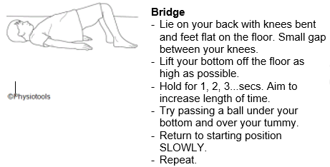  Line walking/Line jump  - Tape a line on the floor about 5m long using masking tape.  - Walk forwards along the line, using your arms to balance.  - Once you have mastered walking forwards, try other ways. For example, heel-to-toe, walking sideways, walking backwards, walking on tip-toes, walking on heels.  - Start at one end of the line and jump from side to side to the other end. Make sure you bend your knees and keep your feet together.
 | Include the child in regular Gym Trail (small group gross motor sessions) to enable them to practise their skills.
 | Ensure the child is wearing supportive footwear.
Child struggles to coordinate their body to perform new or unfamiliar motor tasks or movement sequences | Offer regular opportunities to practise motor planning and bilateral coordination activities. These ideas can be incorporated into Gym trail, PE lessons, playtimes and leisure activities at home. They should be completed at least 3 times a week for 15-20 mins e.g. see next page  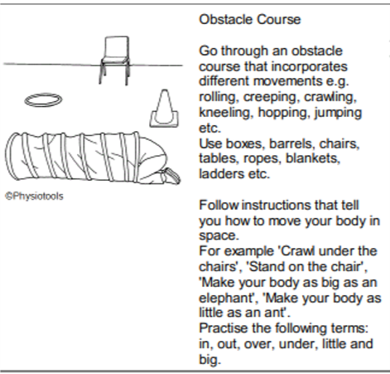  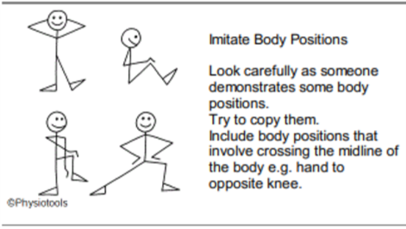  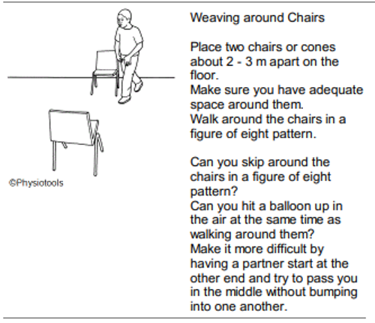  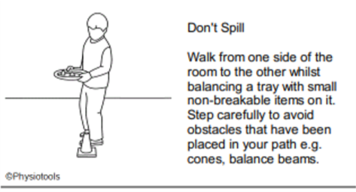  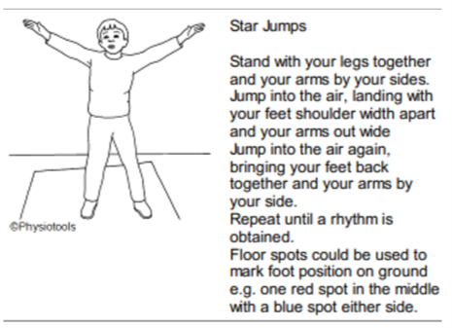
 | Include the child in regular Gym Trail (small group gross motor sessions) to enable them to practise their skills.
Remember the following:
- Demonstrate for the child to copy
- Talk the activity through, describing exactly what the child’s arms/hands/legs need to do.
- Break the activity down into parts and practise each of these first.
- Visual cues e.g. spots on the ground for them to position their limbs on may also help.
- The child may need more repetition than others when learning new tasks.
- You may need to give the child some “hands on” prompting / help to give the child a “feel” of the required movement or position.
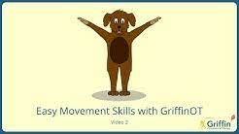
YouTube videos, for example those produced by Griffin OT can be used to guide children through easy movement sequences and could be used as part of a warm up.
Child trips and falls and bumps into people and objects  Child appears clumsy and awkward in their movements | Refer to above strategies
 | Consider the child’s position in the classroom e.g. move them closer to the door to reduce their need to negotiate a busy classroom
Consider that the child may not be paying attention to their environment and this is why they are having accidents.
- Encourage them to slow down
- Encourage them to look where they are going
 | Consider offering more focussed activities during playtimes e.g. set up games which will encourage the child/children to stay in one area of the playground rather than moving around the busy playground where they may be more at risk of tripping/bumping into others etc.
Child is floppy and requires increased effort to initiate movements  Child fatigues quickly | Offer ‘alerting’ activities to help prepare the child to engage their muscles more easily. Fast, exciting movement, with frequent change in direction will help ‘wake them up’.
Provide opportunities for the child to practise some core strengthening exercises. These ideas should be completed in PE/Gym Trail sessions and at home at least 3 times a week for 15-20mins.
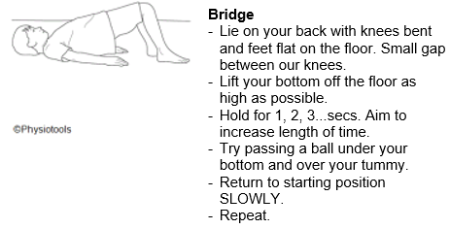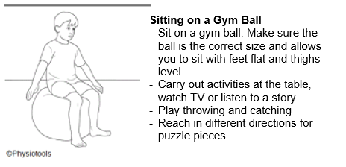

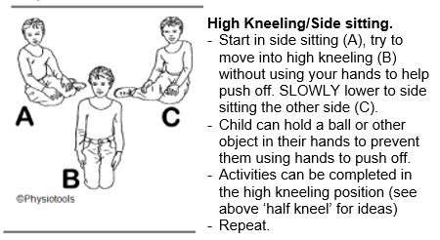
 | Allow the child to have regular rest breaks to avoid them becoming too fatigued and unable to continue. It is important that they continue to participate in physical activity to help build their stamina and strength.
Also see;
https://www.cambscommunityservices.nhs.uk/cambridgeshire-children's-occupational-therapy/coordination-and-motor-skills---online-learning

