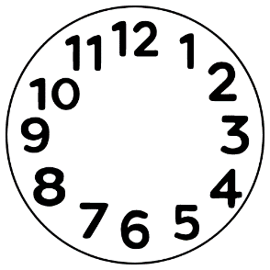
What happened? What did we do?

First:

Next

And then:
Where?
When?

Who?

