Article for family newsletters
Cambridgeshire Peterborough Children’s Health: Expert Advice for Every Age and Stage
Family life is busy and fast paced. Whether you’re raising a tiny baby or an independent young adult, there are many wonderful moments and challenges along the way. Having the right health advice when you need it is crucial.
Introducing your new NHS online resource www.cambspborochildrenshealth.nhs.uk. This platform is the new go-to resource for families like yours, offering expert advice right at your fingertips.
Designed with families for families Cambridgeshire Peterborough Children’s Health is your new tool to help with the everyday questions and health challenges of parenting. It's a platform where medical accuracy meets family-friendly usability.
Whether you're using a phone, tablet, or laptop, you can quickly find what you need. The information is accessible and adaptable, allowing you to translate, download, and change reading preferences to suit your family’s needs.
Cambridgeshire Peterborough Children’s Health offers a mixture of general and specialist NHS advice for families with children aged 0 to 19. Covering many topics including:
- Behaviour, emotions and mental health
- Child development and growing up
- Common illnesses
- Feeding and eating
- Moving and being active
- Peeing pooing and toileting
- Sleep
- Speech, language and communication
- Staying safe and accident prevention
Every child's journey is different. You can also find more specialist information on topics such as sensory differences, physical skills development, chronic fatigue, autism and more. This platform is aiming to help you with your family's unique questions.
Built by local professionals from NHS children’s services, there are also details to access support from the Health Visiting and School Nursing Service and many children’s specialist services. This includes Speech and Language Therapy, Occupational Therapy, Physiotherapy, Emotional Health and Wellbeing, Nutrition and Dietetics, Chronic Fatigue, Specialist Community Nursing and Community Paediatrics.
This is just the beginning, there is lots more planned to grow Cambridgeshire Peterborough Children’s Health as your community’s health resource. If you’d like to get involved, we’d love to have you! Just fill out the form on our co-production page.
For now, have a look around and visit www.cambspborochildrenshealth.nhs.uk

Bulletin for families
Cambridgeshire Peterborough Children’s Health: Expert Advice for Every Age and Stage
Family life is busy and fast paced. Whether you’re raising a tiny baby or an independent young adult, there are many wonderful moments and challenges along the way. Having the right health advice when you need it is crucial.
Introducing your new NHS online resource www.cambspborochildrenshealth.nhs.uk. This platform is the new go-to resource for families like yours, offering expert advice right at your fingertips.
Designed with families for families, Cambridgeshire Peterborough Children’s Health offers a mixture of general and specialist NHS advice for families with children aged 0 to 19.
For more information visit the dedicated families blog post ‘Expert Advice for Every Age and Stage’

Assets
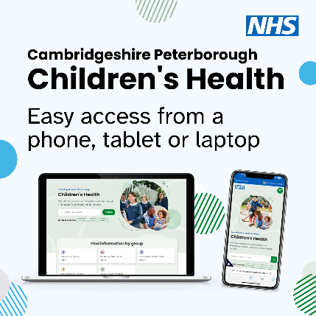
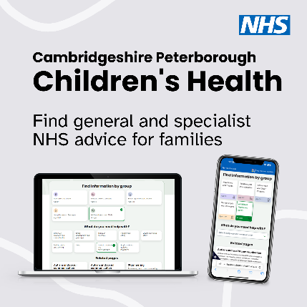
To use an asset in your article or bulletin, right click on an image below and select ‘Save as Picture’.
