Managing Periods

Area of Difficulty | Strategy | Tick when strategy has been tried and add comments.
Child is anxious about starting her periods and worried about how she will manage her personal care | There are many useful books that can be read with girls to help them begin to understand the changes to her body. E.g. https://www.robynsteward.com/the-autismfriendly-guide-to-periods
 | Begin practising with sanitary products before they are needed- ensure your child knows how to open sanitary towels and place them in her pants correctly. Some girls may benefit from opportunities to wear pads from time to time before starting their periods, to get used to the feel of the pad in her pants.
Child gets messy when changing a sanitary pad | Reassure your daughter that this is perfectly normal and most girls have the same difficulties when they are learning to manage their periods
 | Keep a small pack of baby wipes with her sanitary pads to help with any clean up that is required.
 | Keep a change of pants/trousers and fresh pads in her school bag.
 | Keep a bin in reaching distance of the toilet so that she can dispose of used pads whilst still sat on the toilet.
Child struggles to sequence the stages of the task | Use visuals: Step by  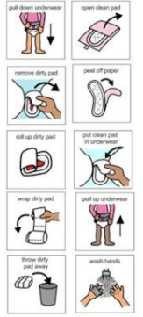  step pictures like those  available from websites  such as Do 2 Learn can  help with learning the  steps of the task. Keep  the pictures next to the  toilet and prompt your  daughter to look at the  next picture in the  sequence rather than  telling her what to do.
 | Consider period pants – which are available from the high street stores.
Child is often unprepared for when her period begins | Help your child keep track of her periods by marking on a calendar when her period starts and ends. This will help your daughter learn to predict when her next period is due so that she is prepared and has pads with her.
 | Keep spare pad and knickers in school bag

