Ball Skills

Children can struggle to learn basic ball skills for a number of reasons. Some are scared of the ball and therefore lack confidence to practise. Others struggle to develop the correct timing and eye-hand coordination. Some children struggle to focus on the ball and are distracted during the activity and therefore have limited success. Some children find throwing and catching activities can be exciting and they therefore struggle to remain focussed and regulated which impacts on their accuracy.

These ideas should be completed in PE/Gym Trail sessions and at home at least 3 times a week for 15-20mins.

Area of Difficulty | Strategy | Tick when strategy has been tried and add comments.
Child has difficulty with timing to catch | 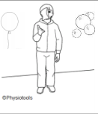  Consider using larger beach balls, balloons, bubbles (they move more slowly and give the child time to react and develop their eye-hand coordination)
 | Provide verbal cues to help with timing e.g. “ready, steady (throw the ball)...catch”
 | Encourage child to start with their hands by their side, rather than just expecting the ball to be thrown onto their outstretched arms.
Child is easily distracted when catching | Remind the child to “watch the ball”
 | Break the task down by giving a numerical target to aim for e.g. try to catch 5 balls before having a break and trying again.
 | Provide additional visual cues to support the child to remain focussed e.g. use skittles, hoops etc to aim at
Child struggles to throw the ball accurately at a target | Use a hand over hand technique to allow the child to feel the correct smooth movement. Encourage the child to end with their hands pointing to the target.
 | Encourage them to start to throw from the front of the body using two hands, rather than from the side.
Use graded targets for the child to throw at. Start with large targets and progress to smaller targets as the child’s skills develop.
___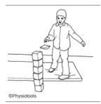 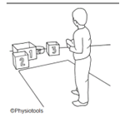
Child struggles to kick a ball | Encourage the child to practise the movement needed for kicking without the ball. Stand on one leg and swing the other leg backwards and forwards from the hip. They may need to hold onto something to help balance.
 | Encourage the child to sit on a chair, or stand and hold onto an adult’s hand for support, and kick a stationary ball. Once the child has gained this skill start rolling the roll for the child to kick.
 | Once the child is confident provide large targets for the child to kick the ball at.
Also see:
https://www.cambscommunityservices.nhs.uk/cambridgeshire-children's-occupational-therapy/coordination-and-motor-skills---online-learning

