Scissor Skills and Using a Ruler

Children can struggle to grasp and operate standard scissors when they have yet to develop adequate manipulation skills or hand strength. They may try to use two hands to operate the scissors meaning they cannot also hold the paper. Children can struggle to control and guide the paper and can get easily frustrated when they fail. Some children lack safety awareness when using scissors or they may not be developmentally ready to use scissors but need to practise other bilateral activities to develop their skills ready for using scissors in the future. Standard rulers can be difficult to hold in place, particularly when children are focussing on measuring as well.

Area of Difficulty | Strategy | Tick when strategy has been tried and add comments.
Child struggles to hold scissors correctly | Ensure left handed children have access to left handed scissors.  https://www.griffinot.com/difference-left-handed-scissors/
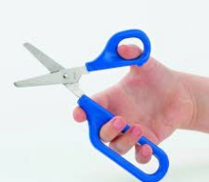
Provide Mini Easi Grip, Easi Grip or Long Loop Scissors which are easier to hold
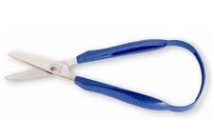
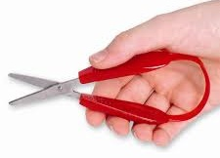

- https://peta-uk.com/shop/mini-easi-grip-scissors-3/
- https://peta-uk.com/shop/easi-grip-scissors/
- https://peta-uk.com/shop/long-loop-scissors/
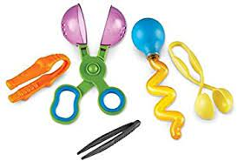
Provide opportunities to practise activities with tongs, tweezers or Handy Scoopers which are held in a similar way but can be a safer option for children with poor safety awareness
 | Provide hand over hand support (position yourself behind the child and place your hands over their hands) to help the child ‘feel’ the correct movement and help them maintain the correct grasp
 | Visit https://www.griffinot.com/scissor-skills-children/ for more ideas.
Child struggles to hold and guide the paper | 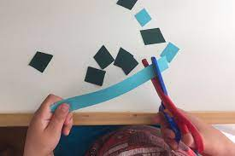  Keep the paper small. Start with thin strips of paper, Play Doh sausages or straws etc and just practise snipping...
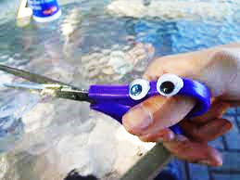
Encourage the child to hold scissors and paper with their thumb uppermost. A sticker on each thumbnail or googly eyes on the scissors will act as a visual prompt.

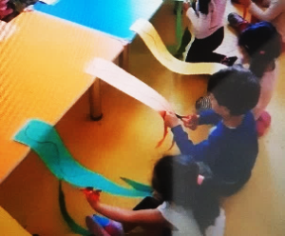
Don’t be tempted to hold the paper for them, they need to learn to operate the scissors in one hand and hold the paper in the other hand. Instead of holding the paper for them, tape one end to the table and let the child cut from the other end.
 | Encourage and prompt the child to move the hand holding the paper as they cut along the line. Numbered dots for where to position thumb may be useful.  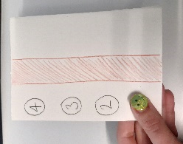  E.g. if child is guiding the paper with their left hand, place numbered dots along the left hand edge of the paper and call out the corresponding number when they need to move their hand as they progress with the scissors along the line.  A coloured dot and corresponding coloured sticker on the child’s thumbnail would be helpful. | 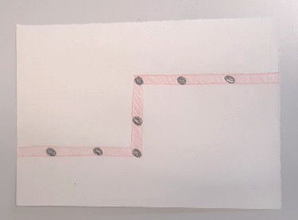
 | Provide hand over hand support (position yourself behind the child and place your hands over their hands) to help the child ‘feel’ the correct movement and help them maintain the correct grasp.
Child lacks accuracy when cutting. | Make sure the task is set at the ‘just right level’. If the child feels the task is unachievable they are likely to take little care over their work.
Use graded scissor activities i.e. start with cutting between wide, straight pathways on small pieces of paper.
When the child is more confident and able, you can slowly make the paper larger and the pathways narrower and introduce changes in direction.
Then ask the child to cut on the line, rather than between a pathway.
Remember to keep the paper small (1/4 A4 is about right).
 | Draw dots along the line they are cutting along to help focus and slow them down. They could score points for every dot they are able to cut through.
Child has difficulty holding a ruler still | Provide a ruler with a handle or non-slip ruler  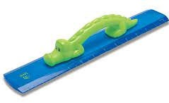  https://www.amazon.co.uk/Alligator-Easy-Grip-Ruler-Pack/dp/B01LA6VR7W  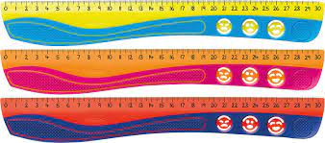  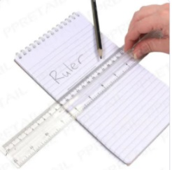  https://www.thedyslexiashop.co.uk/ maped-kidy- grip-ruler-30cm.html  https://www.whsmith.co.uk/products/ classmaster- finger-grip-ruler-clear-10-pack-fgr10/5055353605377.html
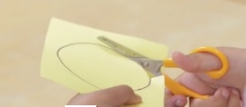 | Also see;  https://www.cambscommunityservices.nhs.uk/cambridgeshire-children's-occupational-therapy/paper-pencil-and-scissor-skills/scissor-skills

