Toileting

For children that require help with continence, useful information can be found https://www.cambscommunityservices.nhs.uk/what-we-do/children-young-people-health-services-cambridgeshire/cambridgeshire-0-19-healthy-child-programme

The strategies below are intended for children that are yet to master the practical aspects of toileting.

Area of Difficulty | Strategy | Tick when strategy has been tried and add comments.
Child struggles to sit on the toilet stably | Ensure that the child’s feet are supported, they may require a foot box under their feet
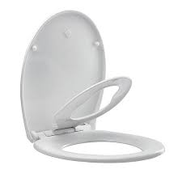
Consider reducing the size of the toilet seat aperture to prevent the child slipping through. Family toilet seats or inserts can be used.

 | Consider allowing the child to use the disabled toilet where they can hold onto a rail for support
 | Consider if some core stability activities could be completed to help their posture and balance (see sitting posture worksheet for ideas).
Child struggles to sequence the stages of the task | Use visual cues, such as a photo, illustration or symbol to prompt. Follow a consistent sequence, for example:  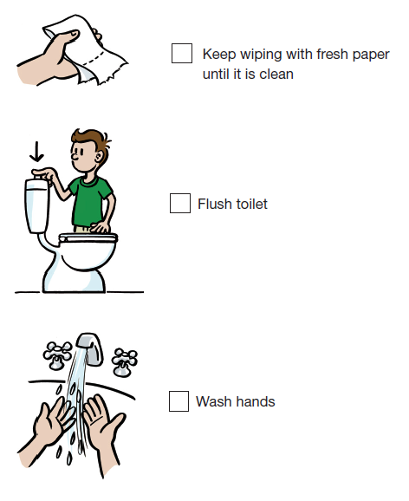  https://continencevictoria.org.au/wp-content/uploads/2019/04/EasyGuideBook.2nd-Ed.-pdf.pdf
Child struggles with bottom wiping | Backward chaining -the adult will begin the sequence but the child will finish the task, gradually achieving more steps along the way. E.g.…  1. The adult supports the whole toilet routine but allows the child to flush.  2. The next step could be the adult allows the child to throw the used toilet roll in the loo and then flush.  3. the adult completes all but the final wipe of the child’s bottom. the Child completes the final ‘clean’ wipe, and flushes.  Etc, etc, etc
 | Use hand over hand guidance. Encourage them to hold the toilet tissue and guide their hand as they attempt to wipe themselves –this gives them more feedback and helps them to orientate to where they are wiping.
 | Use wipes or damp tissues so that the child/young person can feel where they have wiped. Sometimes cheap toilet roll that is rougher provides more feedback and awareness of where has been wiped
Child uses too much or too little toilet paper and/or soap. | Count out loud the number of toilet sheets required
Mark on the wall with colourful tape/stickers to provide a visual guide of how much paper to pull out.
Using a toilet roll holder with a cover can help with tearing off paper using an upward motion.
Alternatively, show your child how to hold with one hand and tear with the other.
 | Use alternative soap and toilet paper dispensers e.g. motion sensor soap, individual sheets rather than roll of toilet paper and wet wipes.

