Washing Body and Hair
Becoming independent in personal care is an important life skill that can give a young person a sense of pride and achievement. Even becoming independent in parts of the task can help a young person to feel engaged and more confident.
Area of Difficulty | Strategy | Tick when strategy has been tried and add comments
Child struggles to complete steps of the task and/or forgets to wash body parts | Use visuals e.g. a diagram labelling body parts that need to be washed. Sample visuals can be found on https://www.nhsggc.org.uk/kids/lifeskills/self-care/looking-after-my-body/  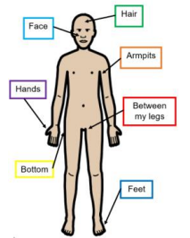  Start with just a few body parts for the child to practise and you help with the rest, and slowly add in more body parts
Many children benefit from visual prompts of the steps of a routine such as showering. These are available from websites such as Do 2 Learn. Have the pictures laminated and displayed where the child can see them and prompt your child to look at the next picture in the sequence rather than telling them what to do.

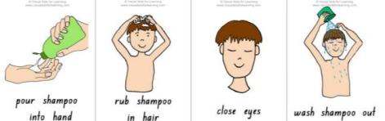
 | Hand over hand support may be required to guide their hand.
 | A mirror may help your child to see what they are doing.
 | Have a consistent routine where stages of the task are completed in the same way each time
Child struggles to wash hair | A mirror may help your child to wash areas that are more difficult because they are out of sight e.g. their hair
 | Hand over hand support may be required to guide their hand and to guide how much pressure they need.
 | Break the task of hair washing down and encourage your child to be confident and independent in one step before moving onto the next, for example encourage your child to put shampoo on their hand then head, you then take over for lathering the hair and rinsing.
Child struggles to dispense soap and/or shampoo | Use soap in a pump bottle as it can be easier to control than turning and squeezing a bottle with one hand into the other.
Child spends a long time in bath/shower but does not follow steps to clean themselves | Use above strategies e.g. using visual schedule, breaking task down and hand over hand support
 | Set small goals e.g. you put the soap on the sponge then give it to your child to wash their body. Once your child has mastered one step, introduce another aspect of the routine e.g. putting the soap on the sponge
 | Use a shower timer to help focus your child when in the bath/shower.
Child slips in the bath | Have an anti-slip mat on the floor and in the bottom of the bath
Further advice – see our website  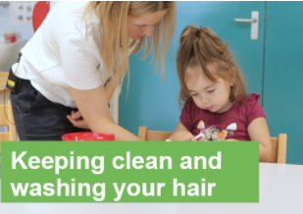 | https://www.cambscommunityservices.nhs.uk/cambridgeshire-children's-occupational-therapy/looking-after-yourself/keeping-clean-and-looking-after-your-hair
Child regularly slips and falls in the bath/shower and/or is unable to get in/out independently /safely | Please contact Occupational Therapy to discuss potential equipment solutions and if a referral is required.

