Cutlery Skills

Children with poor sitting balance and/or attention difficulties can struggle to sit properly at the table. Some children with bendy fingers or poor hand strength and/or in hand manipulation can struggle to grasp cutlery correctly and apply sufficient pressure to spear food with their fork or cut with a knife. Others struggle to coordinate their two hands together to use a knife and fork.

Area of Difficulty | Strategy | Tick when strategy has been tried and add comments.
Child has difficulty sitting at the table | Refer to strategies described in Worksheet B for ‘Sitting Posture and Attention/Focus’
Plate is slipping and moving on table. | Try using non-slip matting (e.g. Dycem) or consider bowls and plates with suction grips.
Child has difficulty holding cutlery correctly | Make sure the child has the correct size cutlery e.g. child size, chunky plastic handles are best
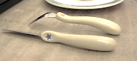
Mark the cutlery to help prompt the child where their index fingers should be with stickers/nail varnish or marker pens
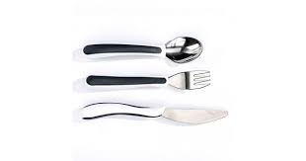
Consider trying adapted cutlery e.g. Nanna’s Manners or NRS Kura Care Cutlery which has a moulded handle and prompt for where to extend their index finger
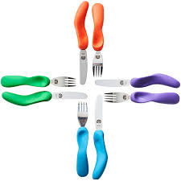

- https://www.nrshealthcare.co.uk/eating-drinking-aids/cutlery-aids/kura-care-adult-cutlery-set (also available in child size)
- https://www.nanasmanners.com/
Child has difficulty loading a spoon or fork  Difficulty in bringing food accurately to mouth | Start with things which stick easily to the spoon, such as thick yoghurt, porridge or mashed potato.
 | Use a bowl with a raised edge, so the child has something to push against.
 | Provide hand over hand support (position yourself behind the child and place your hands over their hands) to help the child ‘feel’ the correct movement and help them maintain the correct grasp
Child is not able to cut with a knife. | Make sure the knife has a serrated edge.
 | Start off using the knife on its own, to practice with play dough or soft snack food. Encourage a sawing action, allowing the child to hold the food with their other hand to begin with.
 | Provide hand over hand support (position yourself behind the child and place your hands over their hands) to help the child ‘feel’ the correct movement and help them maintain the correct grasp
 | Set small achievable targets e.g. encourage the child to attempt to cut up a small amount of food on their plate, and offer support for the rest.
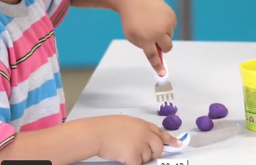 | Also see;  https://www.cambscommunityservices.nhs.uk/cambridgeshire-children's-occupational-therapy/looking-after-yourself/meal-time  for further ideas

