Early Pencil Skills

Handwriting is one of the most complex skills we have to learn. It involves linguistic, cognitive, perceptual and motor components, all of which have to be integrated. Before children can hold a pencil, they need to be able to sit up and move their arm independently of their body. They need to be able to isolate their fingers to hold their pencil. To write, they first need to visually understand the difference between letters. They need to have success with pre-writing shapes. And, then they need to remember how to form the letters.

The relevant pre-writing activities for the child’s area of difficulty should be completed for 5-10mins a day at home/school.

Area of Difficulty | Strategy | Tick when strategy has been tried and add comments.
Child does not show an interest in mark making | Do not force the child to pick up a pencil. Set up an area with an appropriately sized table and chair, and a range of fun and interesting crayons, coloured pencils and paper which they can freely access throughout the day.  If and when they do begin to mark make, you can begin copying the marks/scribbles that they are making whilst providing a verbal commentary e.g. “up and down, round and round”. You can then slowly and subtly start taking turns and encourage them to copy the marks that you make.
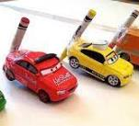
Consider other fun ways to explore simple lines and shapes which may align with their areas of interest e.g. using a car to follow along roads, you could even strap a crayon to the front/back of the car so it makes a mark on the paper.
Multi-Sensory Play
Use various textures to practise drawing horizontal, vertical and circular scribble e.g...
- Shaving foam can be smeared onto a mirror/easel or onto a tray.
- Drawing with finger or stick in a tray of sand/shaving foam/mixture of cornflour and water.

 | Refer to ‘Reluctant Writers’ section for more ideas
Child does not have a hand dominance | Do not force the child to use one hand or the other. Observe them carrying out a range of activities and make a note of which hand they tend to choose.
 | Present objects (e.g. pencils, spoon) in the middle so you don’t influence them to just use the hand closest to the object. Observe which hand they choose to use more often.
 | Provide opportunities to practise activities that require a stabilising and dominant hand e.g. unscrewing lids of containers, wind up toys, musical instruments that are held and hit with a beater.
 | Some children show a clear hand dominance but they swap to the other hand when they get tired or they are unsuccessful with their dominant hand. This should be discouraged; they should be encouraged to rest and then try again with their dominant hand.
Child has difficulties holding a pencil | Refer to https://www.griffinot.com/what-does-good-pencil-grasp-look-like/ and https://www.griffinot.com/supporting-pencil-grasp-development/ (Resource book)
Trial the following:
- Short pieces (2-3cm) of chalk/crayon/chunky pencil or finger crayons https://www.youtube.com/watch?v=Pa1kASdNTW0
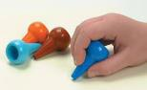
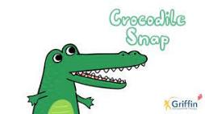
- Provide visual and verbal prompts to remind the child how to position their fingers e.g. ‘Crocodile Snap’ song by Griffin OT-YouTube https://www.youtube.com/watch?v=N6kPcQSSsEY
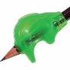
- Grotto Pencil Grip/
Cross Guard Ultra Pencil Grip https://www.griffinot.com/pencil-grip-reviews/
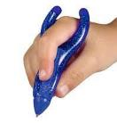
- Twist n Write Pencil or PenAgain (‘Rocket’ pencil/pen)

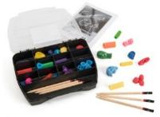
- The ‘Get a Grip’ Kit available from TTS includes all the popular pencil grips which can be trialled with the child. https://www.tts-group.co.uk/get-a-grip-pencil-grips/1002033.html?gclid=EAIaIQobChMIgIq59oOG8wIV1GDmCh123QDaEAAYASAAEgKAa_D_BwE

Provide opportunities to practise hand strengthening, in hand manipulation and pincer grasp activities to help develop the hand skills required to hold a pencil. These ideas should be completed in school finger gym sessions and at home at least 3 times a week. E.g.
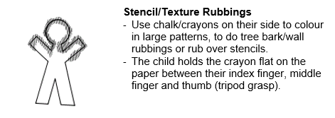
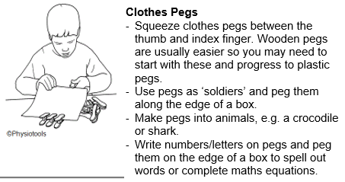
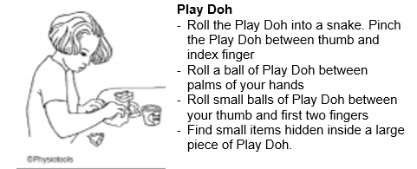

Dough Disco and other similar YouTube videos could be used

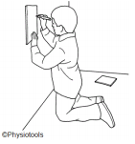
Provide opportunities to practise drawing at a vertical surface e.g. paper on the wall, easel, white board. This will help in the development of shoulder stability/control and promote a good wrist posture and pencil grasp.
Child has difficulties controlling a pencil | Firstly, check their pencil grasp and consider the above strategies if necessary.
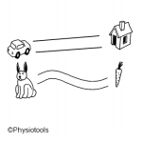
Provide opportunities to practice graded pencil control pathways and mazes i.e. starting with wide straight pathways and over time progress to narrow curved pathways with multiple changes in direction.

Then ask the child to draw on the line, rather than between a pathway.
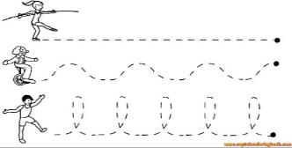

https://www.twinkl.co.uk/resources/literacy-eyfs-early-years/early-years-writing/early-years-fine-motor-skills-pencil-control/4
You may need to draw dots at intervals along the pathway/line to keep the child focussed. They could score points for each dot they draw through.
Child struggles to apply appropriate pencil/pen pressure | Firstly refer to advice regarding ‘difficulties holding a pencil’ above.
Activity ideas and strategies for children that press or grip too hard:
- Write or draw with a sharp pencil on a piece of paper placed on the carpet or over a flat piece of play dough or carbon paper. Try not to rip the paper or make an impression on the dough/carbon paper
- Use self-propelling pencils that will snap if pressed too hard (avoid this strategy with children that are easily frustrated).
- “Light-up pens” press so the light doesn’t come on.
- Colour in a picture using light grey, medium grey and dark grey. Then discuss how applying different amounts of pressure changes the shade of grey.
- Writing/drawing on a whiteboard or laminated piece of paper. Aim to avoid making the pen squeak.
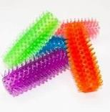
- Try using a Kush-N-Flex (spikey) pencil grip which can help the child to grip the pencil less tightly https://www.tts-group.co.uk/kush-n-flex-sensory-pencil-grips-10pk/1004742.html
- Provide chunky pens and pencils which will enable a more stable grasp and reduce the effort required
- Place Blu-Tack around a pencil approximately 1cm from the drawing tip and avoid making an impression in the Blu-Tac when holding it.
- Encourage regular rest/stretch breaks
Activity ideas and strategies for children that don’t press hard enough or grip too lightly:
- Use chalk or crayons on their side to do tree bark/brick wall rubbings or rub over stencils. Child holds the crayon flat on the paper between their index finger, middle finger and thumb (tripod grasp). Encourage the child to apply enough pressure so they reveal the stencil underneath.
- “Light up pens”- press so the light comes on
- Write or draw with a felt pen or gel pens, or soft lead pencils which allow the child to succeed more easily.
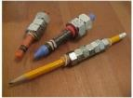
- Provide chunky pens and pencils which will enable a more stable grasp
- Try weighted pens/pencils during colouring/drawing activities. https://www.sensorydirect.com/blog/make-weighted-pencil/
Child has difficulty drawing simple lines and shapes | Children need to be able to recognise shapes before they are able to copy and reproduce them.  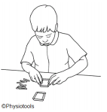  Creating shapes with objects is easier than drawing them. Try activities such as...  - Lolly Sticks  - Start with copying simple lines and shapes from an example produced by an adult (rather than a 2D pattern cards).  - Pattern card templates can be downloaded from online resources such as Twinkl but are more difficult to copy from than a physical example.  - Remember to break the design down into parts.  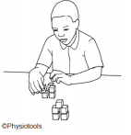  - Verbally discuss the design e.g. ‘on top of’, ‘next to’ etc.  2. Block/Brick Designs  - Ask the child to copy simple block designs from a model made by an adult. Some children may need to watch the adult demonstrate building the model.  - Start with just 3 blocks of the same colour. Over time you can introduce more blocks and different colours and make sure that the child copies the colours accurately.  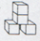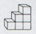  - Talk about the position of the blocks in relation to each other e.g. ‘on top of’, ‘next to’, help the child to identify if their attempt is ‘the same’ or ‘different’.  - Later, the child can copy block designs from 2D pictures on a card rather than a model.
Multi-Sensory Shape Practise
Use various textures to practise drawing:
| ─ o + / □ \ X ∆ ∩ U
- Shaving foam can be smeared onto a mirror/easel or onto a tray.
- Writing with finger or stick in a tray of sand/shaving foam/mixture of cornflour and water.

Provide hand over hand support to help the child ‘feel’ the movement.
Visual cues such as dots may also help create the plan.
 | Progress from tracing over a shape to joining dots.
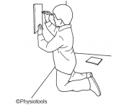
If a child is struggling with spatial concepts such as ‘top’ and ‘down’ it may be helpful to initially work on a vertical surface so top really means top.

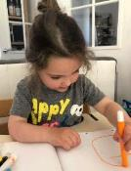 | Also see;  https://www.cambscommunityservices.nhs.uk/cambridgeshire-children's-occupational-therapy/paper-pencil-and-scissor-skills/pre-writing

Reluctant Writers

Common Challenges
- Some younger children do not show an interest in mark making and rarely choose to pick up a pencil.
- Some children struggle to follow an adult’s agenda, and it can be difficult to encourage them to use a pencil.
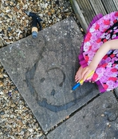
- Child may lack motivation or interest in writing, require a lot of encouragement to initiate the task and ultimately get very little onto paper. They may not see the purpose in writing.
- Child may have a tendency to rush to get the task completed as quickly as possible, resulting in messy handwriting
- Child complains of painful or achy hands. Strategies have been tried, but the aches and pains remain, and child may begin to be reluctant to write.
- Child dislikes the feel of a pen/pencil or the sound of the pencil/pen on the paper.
- Child can express lots of great ideas verbally, but does not reflect these on paper.
- Some children can become anxious about making mistakes. This sometimes prevents them doing any work unless they feel confident they can do it perfectly

Area of Difficulty | Strategy | Tick when strategy has been tried and add comments.
Reluctant writers of all ages | - Make sure the writing task is set at the ‘just right level’ so that the child feels able to achieve, rather than overwhelmed by the task. You may need to reduce the expectation of how much writing is completed in order for the child to engage at all.  - Keep sessions short – up to five minutes initially. Alternate 5 minutes of handwriting practice with 5 minutes of a fun activity or treat, then return to handwriting practice. A visual timer or sand timer could be used to help the child work for the time set, and know that the task will end.  - Encourage the child to take regular rest breaks, not only to rest their hand but also allow a ‘brain break’.  - Use of a ‘Now and Next’ approach may be helpful
Reluctant Pre-writers | - Set up an area with an appropriately sized table and chair, and a range of fun and interesting crayons, coloured pencils and paper which they can freely access throughout the day.  - If and when they do begin to mark make, you can begin copying the marks/scribbles that they are making whilst providing a verbal commentary e.g. “up and down, round and round”. Slowly start taking turns, and encourage them to copy the marks that you make.  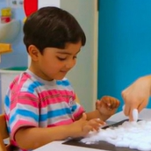  - Refer to the Multi-sensory activity ideas on our other advice sheets or the video on our website to consider more ways to explore simple lines and shapes which may align with areas of interest for example, using a car to follow along roads; you could even strap a crayon to the front or back of the car so it makes a mark on the paper.
Reluctant children that can write independently. | - Remind the child that it is not about quantity of writing, but quality.  - Incorporate art into writing activities – e.g. fold a piece of paper into four quarters and think of four topics. Write one topic on each square. The child can then draw a picture to represent each of the topics before writing about them.  - Choose writing activities with a purpose – allow the child to write about a topic that means something to them so they can see the purpose beyond just learning to write. Fun handwriting activities could include writing birthday cards, secret notes, diaries, letters to Father Christmas and captions to pictures.  - Guided writing – parent/teacher and child write something together. Let the child choose the topic. The adult does the physical handwriting and the child helps to think of, and organise the ideas and sentences. Often a child’s physical writing skills and stamina don’t match their creativity and voice. Guided writing helps them to see what’s possible with writing.  - Children who dislike the feel of the pencil/pen can be given a variety of foam/rubber pencil grips to try. They may prefer to write in pen rather than pencil. Easy flow rollerball pens glide nicely over the paper and are generally not ‘scratchy’ like pencils or standard handwriting pens.  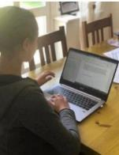  - Consider additional means of recording (e.g. a scribe, typing, dictation), that the child may be more motivated by, and therefore be more able to demonstrate their learning and ideas more accurately. See additional advice sheet on use of ICT for more details.
Fear of Failure | - Spelling and grammar are important, but only as a way to help us communicate thoughts and ideas. Focus on the child’s ideas first and leave spelling/grammar for the revision process. Encourage children who are worried about spelling to write down their whole thought in their best-guess spelling and check the spelling afterwards.  - A Social Story can be helpful to reassure that it is okay to make mistakes.  - Allow use of a rubber initially, then gradually limit use, e.g for tasks they will find difficult, but not for routine tasks.  - Erasable pens may give the child confidence to write in pen as they can erase any mistakes

