Dressing

Children can have difficulties sequencing the stages of dressing or staying focussed and on track. Children with fine motor difficulties can find buttons, zips and laces challenging. It is common for young children to get clothes on back to front, inside out or shoes on the wrong feet but some older children continue to struggle with this, particularly in busy classroom environments where they are easily distracted.

Area of Difficulty | Strategy | Tick when strategy has been tried and add comments.
Child does not know how to start getting dressed | Establish a routine of putting clothes on in the same order each time, so for example, vest first, then pants.
 | Lay clothes out on a surface/table in the order they will be put on, so underwear would be placed on top.
Child struggles to remember the order of how to get dressed | Create a picture dressing schedule. This would remind the child of the sequence for dressing. Photos or pictures could be stuck on with Blue tack or Velcro, and pulled off by the child as they go.
Child struggles to undress themselves | Use a “Forward Chaining” approach. This approach is best used when the beginning of the task is easier than the end e.g. the child removes their arms from a t-shirt and the adult finishes the task by pulling the t-shirt off over their head.
 | Practise with loose clothing. Make sure clothes are not too tight, it may help if they are one size bigger.
Child struggles to dress themselves | Use a “backward chaining” approach.  - Complete all the steps of the task for your child/young person except for the last one i.e. you put their t-shirt over their head, push their arms through and they pull it down.  - Practise, practise, practise this step until your child/young person can do it without your help.  - Now complete all the steps except for the last two i.e. you put their t-shirt over their head, push their first arm through, but they push their second arm through and pull the t-shirt down.  - Keep going like this until they can do all of the steps. E.g.  1. Child lays the t-shirt front side down on the bed/floor/table.  2. Child picks up the t-shirt and places it over their head, pushes both arms through the sleeve openings and pulls down the t-shirt.
Try these ideas during Gym Trail or PE
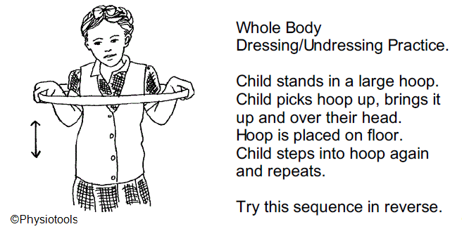
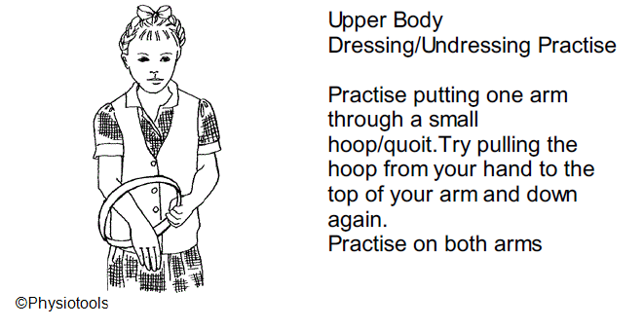
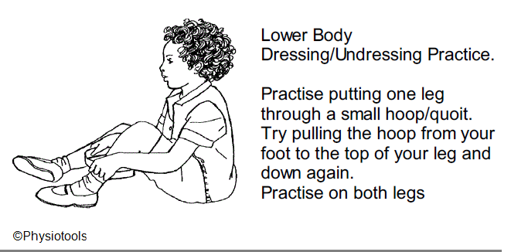

Child struggles to put socks on | Use “backward chaining” approach...  First – adult puts the sock on the child’s foot and the child pulls it up their leg  Then - adult bunches the sock up and puts it over the child’s toes and the child does the rest.  Finally- adult bunches the sock up and hands it to the child who does the rest.
 | Tubular socks with no specific heel position can be a good sock to start with. As the child develops their dressing skills introduce heeled socks.
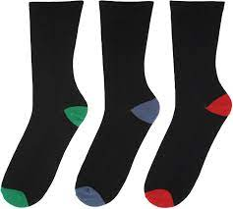
Use socks with coloured toes and heels or pictures on top to help the child with correctly positioning the sock on their feet

Child struggles putting on shoes. | Make sure child is supported, either sitting on a chair or against the wall, or on the bottom stair.
 | Child can place their foot on a raised box to enable them to reach more easily.
 | To help the child put the shoe on the correct foot, cut a simple picture (e.g. smiley face) in half. Stick one half in each shoe or write one half of the child’s name in their left shoe and the other half in their right shoe. The child has to match the picture up or complete their name to know which way round their shoes go.
Child loses arm holes when putting on a t-shirt, jumper or coat | Lay clothing flat in front of the child with sleeves showing. Place arms into garment first so sleeves cannot get lost and then put head in.
 | Drape coat/zip up jumpers over the back of a chair (with lining facing outwards and sleeves freely hanging). Child sits on chair and puts arms in sleeves before standing.
 | Child puts hood on first and then slips arms into sleeves
Child puts clothes on inside out or back to front | Try not to automatically correct a mistake. Instead place the child in front of a mirror or just ask them to see if they can identify where they have gone wrong
 | Remind the child that labels need to be on the inside and often the back of clothing
 | Provide the child with t shirts or jumpers that have a picture or logo on the front of them. This can be a useful reminder to make sure the picture is at the front
 | Encourage the child to lay garments face down on a table/bed
 | Encourage the child to help sort clothes as they come out of the washing machine/tumble dryer. They can practise turning things the right way around before sorting them into piles. Alternatively, they could practise with PE bibs.
Child struggles with zips and buttons | Use “backward chaining” i.e. encourage the child to pull the ‘pull tab’ up once an adult has put the ‘pin’ into the ‘box’- see below  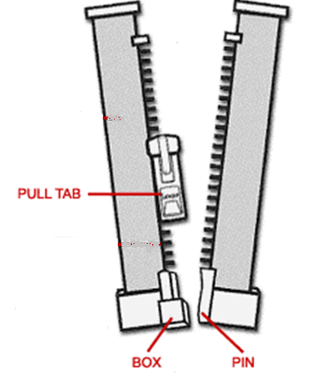
 | Encourage the child to open and close a variety of bags/clothes with zips and buttons. Fun things can be hidden inside to interest them.
 | Attach a key ring or small pieces of ribbon to the ‘pull tab’. This will make it easier for a child to grasp.
The child needs to hold onto the pin side of the garment while pulling the zip up with their other hand, otherwise the pin will come out of the box.
Verbally remind the child, tap the hand that they should use to pull the ‘pull tab’ or use a mark/stitch a cross where the child needs to keep holding the garment while using the other hand to pull the ‘pull tab’.
 | Practise buttons and zips on garments laid out in front of the child as they will be able to access and see the fastening more easily.
 | In order to build up confidence start by practicing unbuttoning and unzipping a garment.
 | Choose large buttons and buttons that are a different colour to the garment.
 | Ensure the button hole is slightly loose for the buttons. The hole may need to be snipped slightly. It can also be useful to reattach the button with a looser thread or elasticated thread
 | Elasticated trousers are an alternative if a child is struggling with fastenings. M&S and Asda sell an ‘Easy Dressing’ school uniform range online.
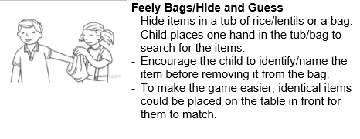
Encourage the child to complete the following activities These ideas should be completed in Finger Gym sessions and at home at least 3 times a week for 15-20mins.
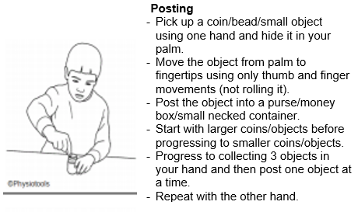
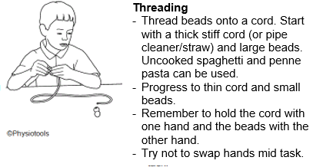
Button snakes and button pizzas are just a couple of examples of fun ways to practise buttons.
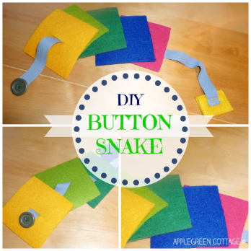
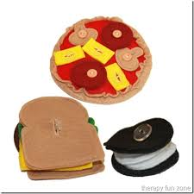

Child struggles with laces | There are different methods for tying shoelaces; the bunny ear method as well as the single loop method. There are a variety of you tube clips illustrating these methods.  Also see; https://www.cambscommunityservices.nhs.uk/cambridgeshire-children's-occupational-therapy/looking-after-yourself/getting-dressed
To keep the initial knot secure whilst the bow is tied on top, wrap the lace over and under a second time before pulling tight.
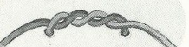
Alternative shoes laces can be used, a few examples are shown below.
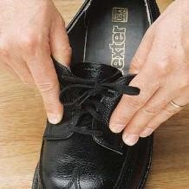
Elasticated Magnetic (Zubits) GREEPER®
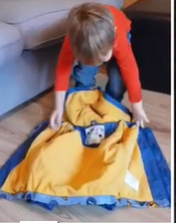 | Also see:  Putting on your coat

